**DOCUMENTATION**

**Project Name: Online Recruitment System**

**Teacher Name:**

**Tapushe Rabaya Toma**

**Daffodil International**

**University**

**Course Name:**

**System Design & Analysis**

**Course Code:**

**SWE312**

Project Done BY

**Sujoy Dey--- 153-35-1359**

**Rakiba Sultana--- 153-35-1304**

**MD Miju Ahmed--- 153-35-1334**

**Sazzatul Yeakin--- 153-35-19-393**

**Online Recruitment**

This is a web base application. That has a login system included different types of users. Admin, Job seekers and recruiters will use this system. Admin can maintain all over the system. Job Seekers can register and create own profile, they can create CV and update all information into profile. By taking information from job seekers system will provide a CV with international format. They can search job by some keyword as like company name, interested position, salary and area name. They can also upload their recent work experience and previous company details for getting better job. Recruiters are post the job circular and find job seekers.

Recruiters update job information into job portal and job seekers can find the job, and apply for the job. There a feedback process in the system, job seekers and requites can comments here and admin can view it .

|  |  |  |  |  |
| --- | --- | --- | --- | --- |
| SRS ID | SRS Name | SRS descriptions | SRS Type | priority |
| FR01 | WEB Based | This is a Web Based system where normal user can search & find job, recruiters offers the job and the admin can handle all over the system | FR | H |
| FR02 | Registration | Normal User need to registered for find and apply job, recruiters need registration to provide job | FR | H |
| FR03 | Job Offers | Recruiters Will provide the job to the system and Admin can handle it. | FR | H |
| FR04 | Search job | Job seekers can see the Job offers and they can apply there | FR | H |
| FR04 | Job seekers | Job seekers can post their recent work place and previous experience to find better job | FR | M |
| FR05 | Recruiters | They can update job info, company details, their requirements for employee | FR | M |

**SRS**

Addition

|  |  |  |  |  |
| --- | --- | --- | --- | --- |
| SRS ID | SRS Name | SRS descriptions | SRS Type | priority |
| FR06 | Search Type | Normal user can search job by using area and salary | FR | M |
| NFR07 | Insert type | Admin insert type in database and normal user , Recruiters can use those type in required filed | NFR | L |
| FR08 | Comments | Recruiters and employers can comments and feedback each other’s | FR | M |
| FR09 | Auto Generate CV | Job seekers can input their data and system will provide their the CV with a international format | FR | M |

|  |  |
| --- | --- |
| Using latter | Full form |
| FR | Functional requirements |
| NFR | Non- Functional requirements |
| H | High |
| M | Medium |
| L | Low |

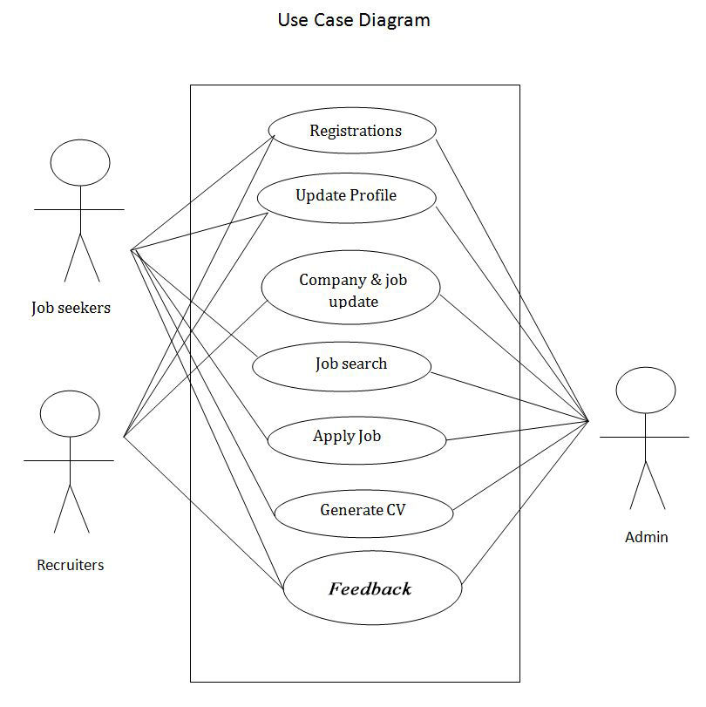

1. **Use Case Name**: Registration

**Requirement Type:** FR

**Priority:** High

**Actor:** Admin, Job seekers, Recruiters

**Description:** Job seekers & Recruiters are registration here and the Admin will approve the registration.

**Precondition:** (1) Fill all the information

(2) Apply for Registration

**Normal Case:**  (1) Go to the web page

(2) Fill all the required

(3) Must have to Submit

**Alternative Case:** (1) Page Reload

(2) Already Registered

1. **Use Case Name**: Update Profile

**Requirement Type:** FR

**Priority:** High

**Actor:** Admin, Job seekers, Recruiters

**Description:** Job seekers & Recruiters can update their profile information & Admin also check and update their information.

**Precondition:** (1) Registration First

(2) Click for Update

**Normal Case:**  (1) Go to update page

(2) Update the required

(3) Must have to Submit

**Alternative Case:** (1) Page Reload

(2) No required included

1. **Use Case Name**: Company and Job Update

**Requirement Type:** FR

**Priority:** High

**Actor:** Admin, Job seekers, Recruiters

**Description:** Recruiters are updating their company and job details here and the Admin will approve the information. Job seekers will be able to see the job.

**Precondition:** (1) Need to registration first

**Normal Case:**  (1) Update company details

(2) Update job information

(3) Must have to Submit

**Alternative Case:** (1) Page Reload

1. **Use Case Name**: Job search

**Requirement Type:** FR

**Priority:** High

**Actor:** Admin, Job seekers

**Description:** Job seekers will be able to search the job here.

**Precondition:** (1) Need to update information from recruiters

**Normal Case:**  (1) Go to search option

(2) Search job

**Alternative Case:** (1) Page Reload

(2) Not Found

1. **Use Case Name**: Apply Job

**Requirement Type:** FR

**Priority:** High

**Actor:** Admin, Job seekers

**Description:** Job seekers will be able to apply for the job and the admin will approve their application.

**Precondition:** (1) N/A

**Normal Case:**  (1) Find Job

(2) Apply for job

**Alternative Case:** (1) Page Reload

1. **Use Case Name**: Generate CV

**Requirement Type:** FR

**Priority:** Medium

**Actor:** Admin, Job seekers

**Description:** Admin will provide a field to get information from job seekers and then they will provide an international format of CV and its auto generate by system.

**Precondition:** (1) N/A

**Normal Case:**  (1) Fill up the field

(2) Must have to Submit

**Alternative Case:** (1) No Information Included

1. **Use Case Name**: Comments/Feedback

**Requirement Type:** FR

**Priority:** Medium

**Actor:** Admin, Job seekers, Recruiters

**Description:** Recruiters & Job seekers will give their feedback here.

**Precondition:** (1) N/A

**Normal Case:**  (1) Give feedback

(2) Get Feedback

**Alternative Case:** (1) N/A

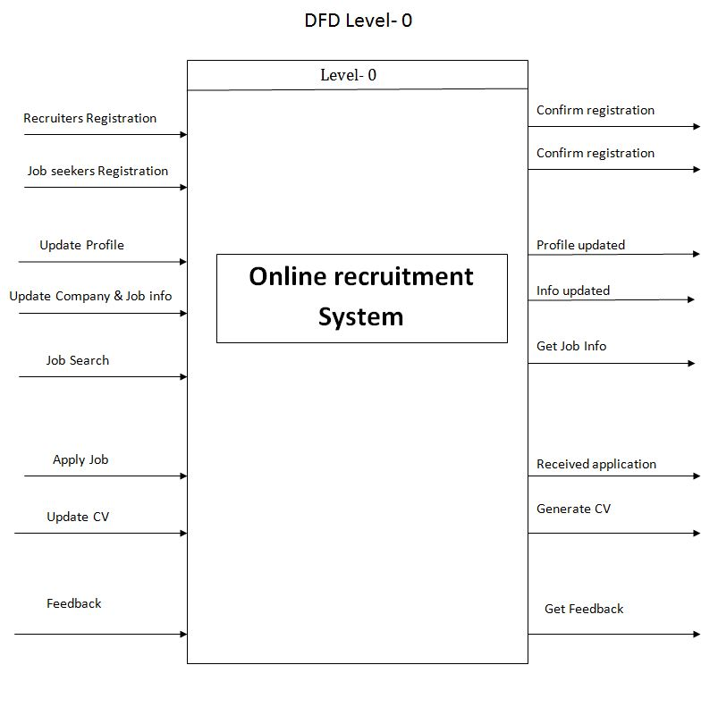

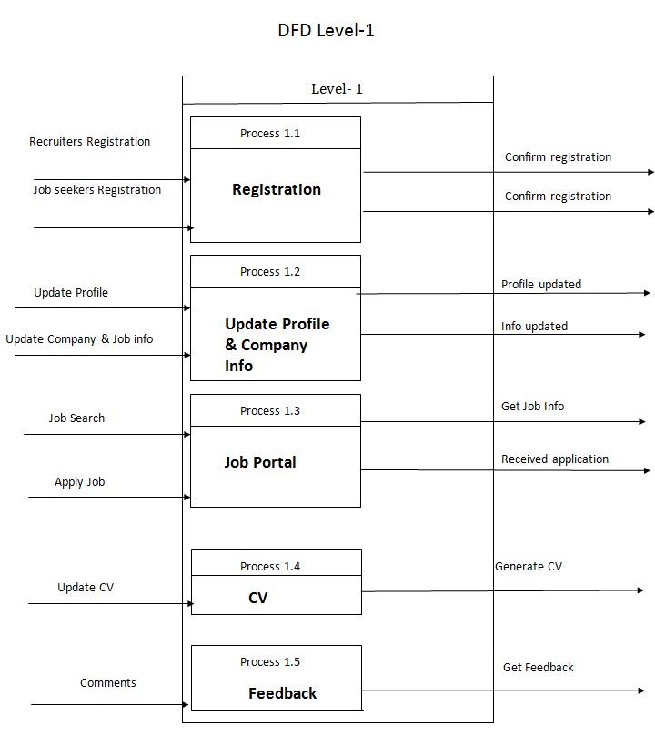

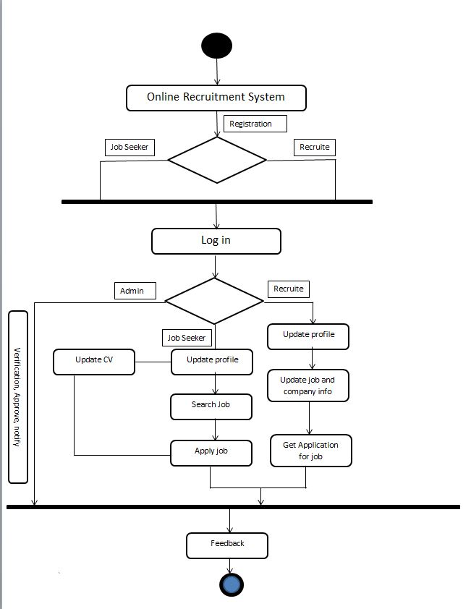

Activity Diagram

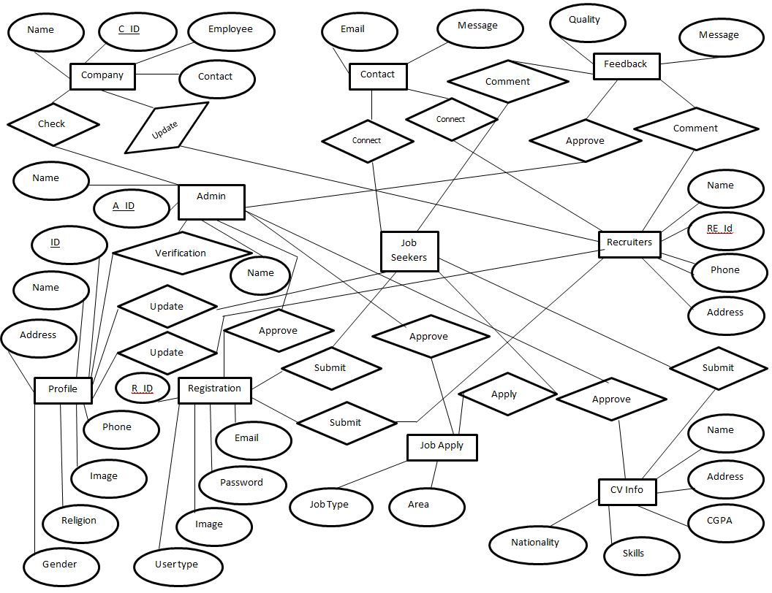

ERD

**Class Diagram**

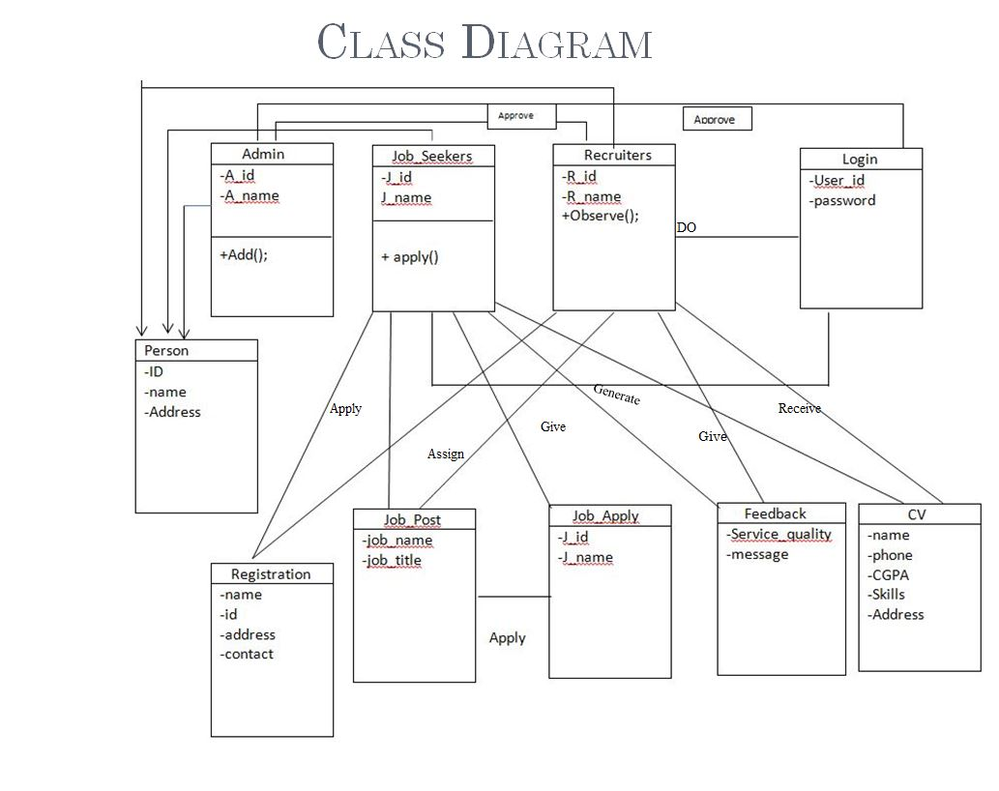

**Sequence Diagram**

